**Review Worksheet: *Homo habilis and Homo erectus***

**Name: ……………………………………………………………..**

*Do these questions, using your learning resources. Look at the “marks” to give you an idea of the level of detail required in the response (formative only – does not count towards your grade). At the end, mark your work, correct it, and fill in the reflection section. Questions marked * require you to use reasoning, inferring and application of knowledge, or perhaps extra research to get the answer. It won’t be right there in the text.*

1: What major difference in diet occurred between *Australopithecus* and *Homo habilis?* What evidence for this change can be seen in the fossil record?

(3 marks)

…………………………………………………………………………………………………………………….

…………………………………………………………………………………………………………………….

…………………………………………………………………………………………………………………….

…………………………………………………………………………………………………………………….

2: Where, and during what range of time did *H. habilis* exist?

(2 marks)

*…………………………………………………………………………………………………………………….*

3: What tools were *H. habilis* known to use?

(1 mark)

*……………………………………………………………………………………………………………………*

5: What major changes occurred in the following areas between *H. habilis and H.erectus?*

(8 marks)

|  |  |
| --- | --- |
| **Feature** | **Change that occurred** |
| Height |  |
| Limb proportion |  |
| Fire Use |  |
| Tools |  |
| Cranial Capacity |  |
| Distribution |  |

6: Circle all of the skulls that you think are likely to be *Homo erectus:*

*Hint: Think about prognathism, brow ridges, skull shape and dentition*

(1 mark)

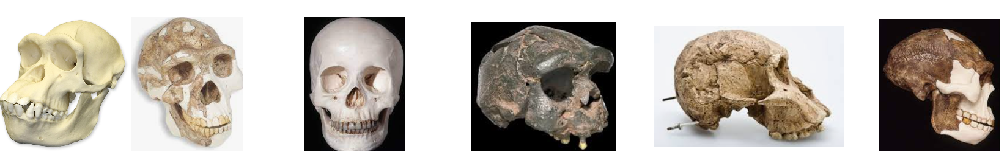



7: Fill in the table below with information about nervous system diseases.

|  |  |  |  |
| --- | --- | --- | --- |
| **Disease** | **Huntington’s (7 marks)** | **Parkinson’s (9 marks)** | **Alzheimer’s (9 marks)** |
| Cause |  |  |  |
| Age of Onset |  |  |  |
| Symptoms |  |  |  |
| Future Treatment |  |  |  |

Go back and mark your work using the marking key provided. What score did you get? /40

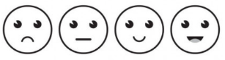*I included enough detail in my answers.*



*I was able to find information in the text/powerpoint presentation.*

*I was able to reason and infer where the information wasn’t directly in the text (questions with *).*

*I marked my work and wrote down any answers where I missed marks.*